**LAPORAN PRAKTIKUM PENGOLAHAN CITRA DIGITAL**

**21. FULL-COLOR IMAGE PROCESSING**



**Disusun oleh :**

**Nama : Garcia Bryan Farrel**

**NPM : 2327250026**

**Kelas : IF41**

**PROGRAM STUDI INFORMATIKA**

**FAKULTAS ILMU KOMPUTER DAN REKAYASA**

**UNIVERSITAS MULTI DATA PALEMBANG**

**2024**

**TUTORIAL : FULL-COLOR IMAGE PROCESSING**

**Goal**

The goal of this tutorial is to learn how to convert between color spaces and perform

filtering on color images in MATLAB.

**Objectives**

* Learn how to convert from RGB to HSV color space using the rgb2hsv function.
* Learn how to convert from HSV to RGB color space using the hsv2rgb function.
* Explore smoothing and sharpening in the RGB and HSV color spaces.

**Procedure**

We will start by exploring the rgb2hsv function.

1. Load the onions.png image and display its RGB components.

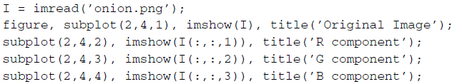

|  |
| --- |
|  |
|  |

1. Convert the image to HSV and display its components.

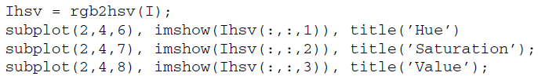

|  |
| --- |
|  |
|  |

**Question 1** Why do we not display the HSV equivalent of the image?

|  |
| --- |
| Kita tidak menampilkan citra HSV secara langsung karena format HSV tidak bisa langsung ditampilkan sebagai gambar berwarna Format HSV tidak bisa ditampilkan sebagai gambar warna tanpa dikonversi. |
|  |

When viewing the components of an RGB image, the grayscale visualization of each component is intuitive because the intensity within that component corresponds to how much of the component is being used to generate the final color. Visualization of the components of an HSV image is not as intuitive. You may have noticed that when displaying the hue, saturation, and value components, hue and saturation do not give you much insight a to what the actual color is. The value component, on the other hand, appears to be a grayscale version of the image.

1. Convert the original image to grayscale and compare it with the value component of the HSV image.

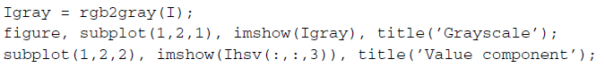

|  |  |
| --- | --- |
|  |  |

**Question 2** How does the grayscale version of the original image and the value component of the HSV image compare?

|  |
| --- |
| Citra Grayscale lebih akurat mencerminkan intensitas terang-gelap. Komponen V di HSV adalah nilai maksimum dari ketiga komponen R, G, dan B yang rumus nya:  V = max(R,G,B) |

Procedures for filtering a color image will vary depending on the color space being used. Let us first learn how to apply a smoothing filter on an RGB image.

1. Apply a smoothing filter to each component and then reconstruct the image.

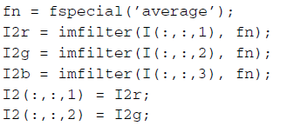

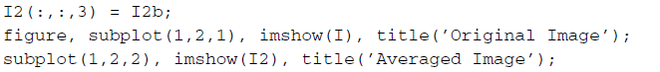

|  |
| --- |
|  |
|  |

**Question 3** Do the results confirm that the RGB equivalent of averaging a

grayscale image is to average each component of the RGB image individually?

|  |
| --- |
| Menerapkan filter average atau rata-rata pada masing-masing RGB secara terpisah tidak setara dengan mengonversi gambar ke grayscale yang hasil akhirnya dan prosesnya berbeda. |

Now let us see what happens when we perform the same operations on an HSV image. Note that in these steps, we will use the hsv2rgb function to convert the HSV image back to RGB so that it can be displayed.

1. Filter all components of the HSV image.

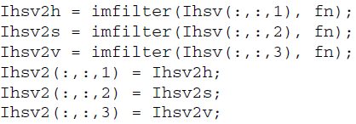

1. Display the results.

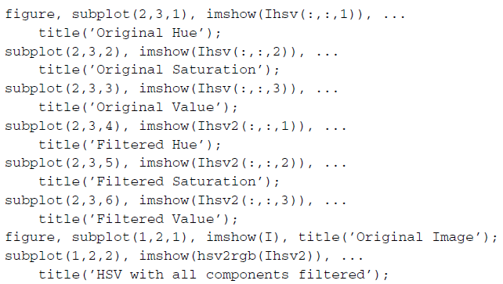

|  |  |
| --- | --- |
|  |  |
|  |  |

**Question 4** Based on the results, does it make sense to say that the HSV equivalent of averaging a grayscale image is to average each component of the HSV image individually?

|  |
| --- |
| Tidak masuk akal averaging atau rata-rata pada gambar grayscale tidak setara dengan averaging pada setiap komponen HSV secara individual. Tidak masuk akal untuk mengatakan demikian. Averaging (perataan) pada gambar grayscale tidak setara dengan averaging pada setiap komponen HSV secara individual. |

1. Filter only the value component and display the results.

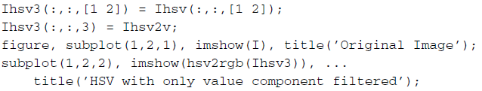

|  |
| --- |
|  |
|  |

**Question 5** How does this result compare with the previous one?

|  |
| --- |
| Setelah memfilter hanya komponen Value memberikan hasil yang lebih baik dan lebih alami, karena hanya mempengaruhi tingkat kecerahan, bukan warna tetapi juga membuat gambar sedikit blur. |

We can sharpen an HSV image following a similar sequence of steps.

1. Sharpen the HSV image and display the result.

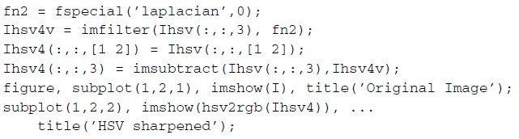

|  |  |
| --- | --- |
|  |  |

**Question 6** How would we perform the same sharpening technique on an RGB image?

|  |
| --- |
| Untuk melakukan teknik *sharpening* yang sama pada citra RGB harus menerapkan filter penajaman misalnya Laplacian pada masing-masing kanal R, G, dan B secara terpisah lalu menggabungkannya kembali menjadi citra RGB. |